27/08/2022

1:-addition of two numbers

Ans:-

Coding:-

#include<iostream>

#include<conio.h>

using namespace std;

int main()

{

int x,y;

cout<<"enter the x and y value";

cin>>x>>y;

cout<<"sum of two numbers"<<x+y;

}

Output:-

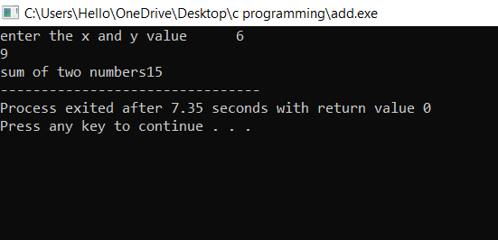

29/08/2022

2:-area and circumference of the circle

Coding:-

#include<iostream>

using namespace std;

main()

{

float r;

cout<<"enter the r value";

cin>>r;

int exp;

cout<<"enter the choice";

cin>>exp;

switch(exp)

{

case 1:

cout<<"area of the circle"<<3.14\*r\*r;

break;

{

case 2:

cout<<"circumference of circle"<<2\*3.14\*r;

break;

}

}

}

Output:-

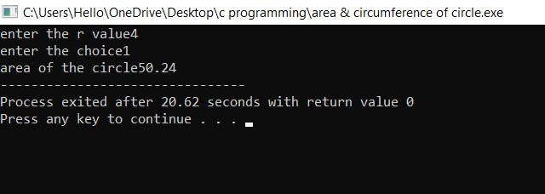

3:-vote eligibility

Coding:-

#include<iostream>

using namespace std;

int main()

{

int age;

cout<<"enter persons age";

cin>>age;

if(age>=18)

{

cout<<"person is eligible";

}

else

{

cout<<"person is not eligible";

}

}

OUTPUT:-

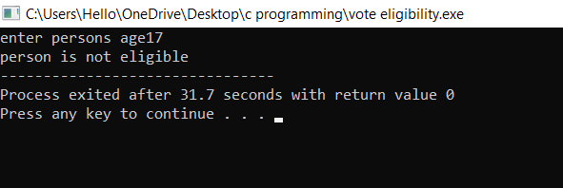

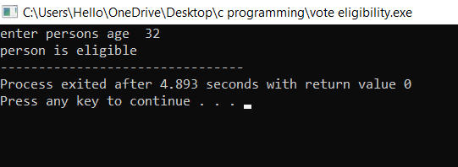

4:-biggest of 3 numbers

Coding:-

#include<iostream>

using namespace std;

main()

{

int x,y,z;

cout<<"enter x,y and z values";

cin>>x>>y>>z;

if(x>y&&x>z)

{

cout<<"x is a biggest number";

}

else if(y>x&&y>z)

{

cout<<"y is a biggest number";

}

else

{

cout<<"z is a biggest number";

}

}

OUTPUT:-

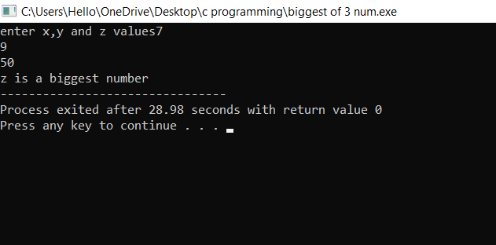

5:-EVEN OR ODD

CODING:-

#include<iostream>

using namespace std;

int main()

{

int n;

cout<<"enter the n";

cin>>n;

if(n%2==0)

{

cout<<"number is even";

}

else

{

cout<<"number is odd";

}

}

OUTPUT:-

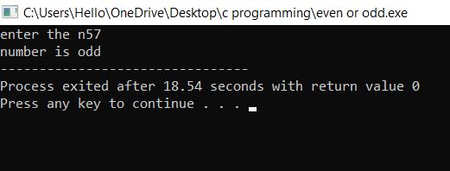

30/08/2022

6:-arthimatic operations

CODING:-

using namespace std;

#include<iostream>

main()

{

int x,y,exp;

cout<<"enter x and y values";

cin>>x>>y;

cout<<"enter the choice";

cin>>exp;

switch (int(exp))

{

case 1:

{

cout<<"addition of two numbers"<<x+y;

break;

}

case 2:

{

cout<<"subtraction of two numbers"<<x-y;

break;

}

case 3:

{

cout<<"multiplication of two numbers"<<x\*y;

break;

}

case 4:

{

cout<<"division of two numbers"<<x/y;

break;

}

case 5:

{

cout<<"modulus of two numbers"<<x%y;

break;

}

default:

{

cout<<"enter the correct values";

break;

}

}

}

OUTPUT:-

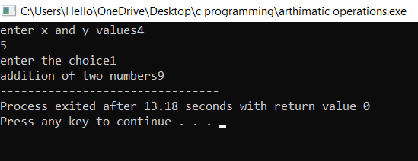

7:-ADD WITH Oops

CODING:-

#include<iostream>

using namespace std;

class add

{

int x,y,z;

public:

void getdata();

void display();

};

void add ::getdata()

{

cout<<"enter x and y values";

cin>>x>>y;

}

void add::display()

{

cout<<"sum of two numbers";

z=x+y;

cout<<z;

}

main()

{

add a;

a.getdata();

a.display();

}

OUTPUT:-

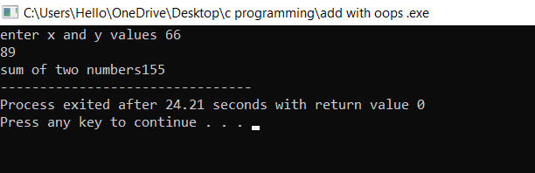

8.VOLUME OF CONE WITH Oops

CODING:-

#include<iostream>

using namespace std;

class cone

{

float r,h,x;

public:

void getdata();

void display();

};

void cone::getdata()

{

cout<<"enter r,h values";

cin>>r>>h;

}

void cone::display()

{

cout<<"volume of the cone";

x=0.3\*3.14\*h\*r\*r;

cout<<x;

}

main()

{

cone m;

m.getdata();

m.display();

}

OUTPUT:-

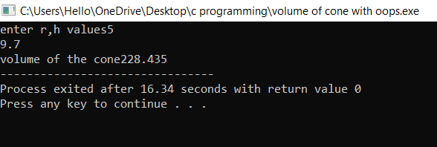

9.simple and compound intrest

CODING:-

#include<iostream>

#include<math.h>

using namespace std;

class intrest

{

float p,t,r,x,y;

public:

void getdata();

void display();

};

void intrest::getdata()

{

cout<<"enter the p,t,r values";

cin>>p>>t>>r;

}

void intrest::display()

{

cout<<"intrerst for money";

x=p\*t\*r/100;

cout<<x;

cout<<"compound intrest";

y=p\*pow((1+r/100),t);

cout<<y;

}

main()

{

intrest m;

m.getdata();

m.display();

}

OUTPUT:-

